**Experiment : 9 Shahnaz Fathima N**

**230701302**

**Form Validation using HTML, CSS, and JavaScript**

**1.Procedure**

**HTML:**

The form consists of two input fields: **Email** and **Phone Number**, along with a **Submit** button. The required attribute ensures that the user must fill in the fields before submitting the form. Specific input types like email help browsers automatically validate the format.

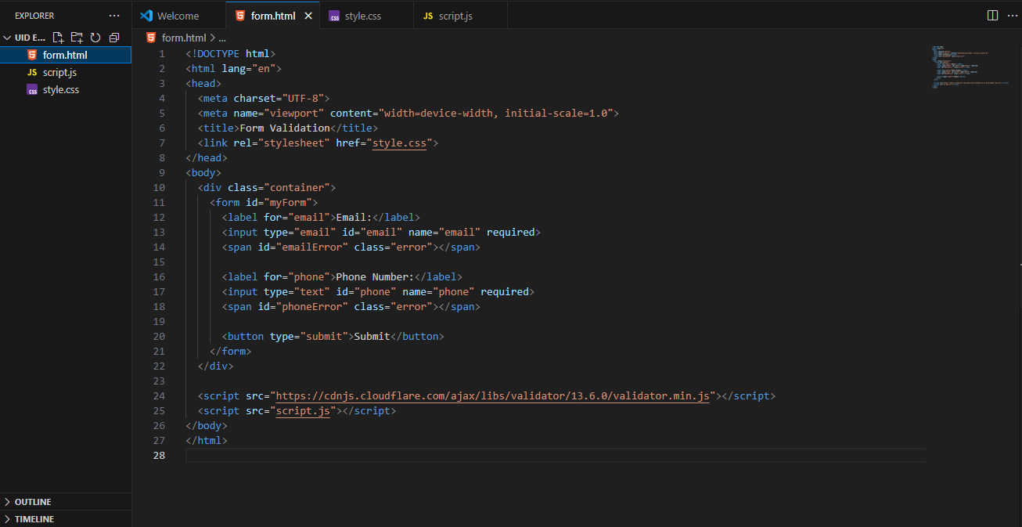

**CSS:**

Styling is applied to make the layout clean and highlight error messages in **red** to easily catch users' attention.

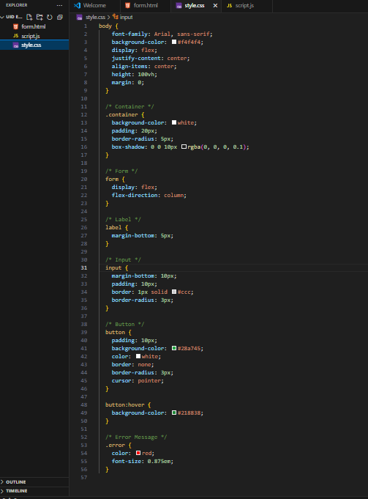

**JavaScript:**

JavaScript is used to further validate the inputs when the form is submitted. It checks:

* If the entered email contains an '@' symbol and a domain name.
* If the phone number is numeric and has the correct number of digits.

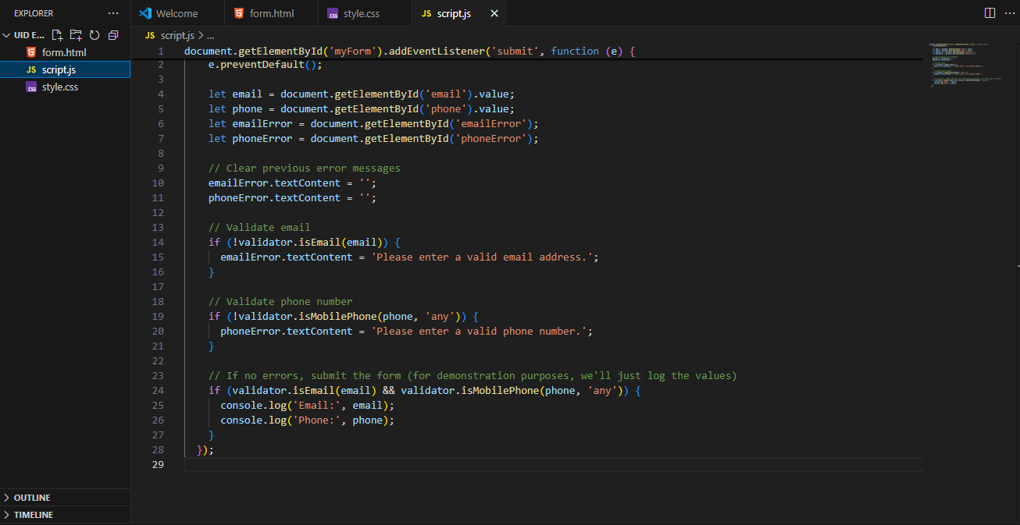

If invalid data is detected, an appropriate error message is displayed below the form without submitting it.

**2. Output Explanation with Screenshots**

**2.1 Valid Inputs Example**

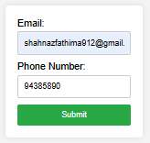

* When a valid email and phone number are entered, no error message appears.
* The form submission proceeds successfully.

**2.2 Missing '@' in Email**

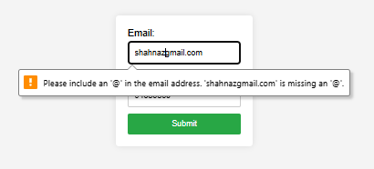

* If the email is missing the '@' character, the browser automatically shows a warning popup.
* This prevents the form from being submitted until a proper email format is provided.

**2.3 Invalid Phone Number (Too Short)**

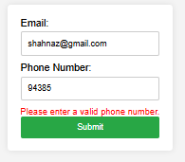

* If the phone number is shorter than expected, a red-colored error message is displayed below the phone number input.
* The message prompts the user to enter a valid phone number.

**2.4 Invalid Email Format**

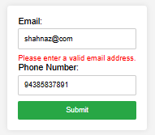

* If the email format is wrong (for example, 'shahnaz@com' without a valid domain), a red error message appears.
* The message prompts the user to enter a valid email address.

**Conclusion**

Using a combination of HTML5 form validation, CSS for styling, and JavaScript for custom validation, user inputs can be properly verified before submission. This improves the reliability of data and enhances the overall user experience.